LAB ASSIGNMENT 01
Artificial Neural Networks
& Deep Learning
From McCulloch-Pitts Neurons to Multi-Layer Perceptrons

TOPICS COVERED
01  M-P Neuron & Logic Gates | 02  Perceptron Learning | 03  MLP & Backpropagation | 04  Weight Initialization

Submitted By | Muhammad Zarar
Roll No | SP24-BAI-039
Subject | ANN and Deep Learning
Submitted To | Sir Anayatullah
Assignment | Lab Assignment 01

TASK  1 | M-P Neuron & Logic Gates  Binary threshold units, gate realization and the XOR limitation

1.1 McCulloch-Pitts (M-P) Neural Model
The M-P neuron is a binary threshold unit. It computes the weighted sum of its inputs and fires (outputs 1) only if that sum meets or exceeds a set threshold θ.
Formula
Output = 1 if Σ (xᵢ · wᵢ) ≥ θ, else 0

1.2 Generic M-P Neuron Function
mp_neuron(inputs, weights, threshold)
- Calculates weighted_sum = sum(inputs * weights).
- Returns 1 if weighted_sum >= threshold, otherwise 0.

1.3 Realizing Logic Gates (Manual Weights & Thresholds)
Gate | Weights | Threshold | Derivation
AND (2-input) | [1, 1] | 2 | Only 1(1)+1(1) = 2 ≥ 2 triggers output 1.
OR (2-input) | [1, 1] | 1 | Any input of 1 gives a sum of 1, meeting the threshold.
NOT (1-input) | [-1] | 0 | Input 0 gives 0 ≥ 0 → 1; input 1 gives -1 < 0 → 0.
AND (3-input) | [1, 1, 1] | 3 | Only (1,1,1) sums to 3, meeting the threshold.
Table 1: Manually chosen weights and thresholds for each gate

1.4 Attempt to Realize XOR with a Single M-P Neuron
XOR outputs 1 when the inputs differ — (0,1) or (1,0) — and 0 when they are the same — (0,0) or (1,1).
Result: IMPOSSIBLE
Reason: The M-P neuron is a linear classifier; it draws a single straight line.
XOR is not linearly separable — no single line can separate (0,0) & (1,1) from (0,1) & (1,0). It requires a multi-layer network.

1.5 Truth Tables (Inputs, Weighted Sum, Output)
AND Gate (2-input) | Weights: [1, 1] | Threshold: 2
Inputs | Weighted Sum | Output
(0,0) | 0 | 0
(0,1) | 1 | 0
(1,0) | 1 | 0
(1,1) | 2 | 1
OR Gate (2-input) | Weights: [1, 1] | Threshold: 1
Inputs | Weighted Sum | Output
(0,0) | 0 | 0
(0,1) | 1 | 1
(1,0) | 1 | 1
(1,1) | 2 | 1
NOT Gate (1-input) | Weights: [-1] | Threshold: 0
Input | Weighted Sum | Output
0 | 0 | 1
1 | -1 | 0
AND Gate (3-input) | Weights: [1, 1, 1] | Threshold: 3
Inputs | Weighted Sum | Output
(0,0,0) | 0 | 0
(0,0,1) | 1 | 0
(0,1,0) | 1 | 0
(0,1,1) | 2 | 0
(1,0,0) | 1 | 0
(1,0,1) | 2 | 0
(1,1,0) | 2 | 0
(1,1,1) | 3 | 1
Tables 2–5: Truth tables (highlighted rows show where the neuron fires)

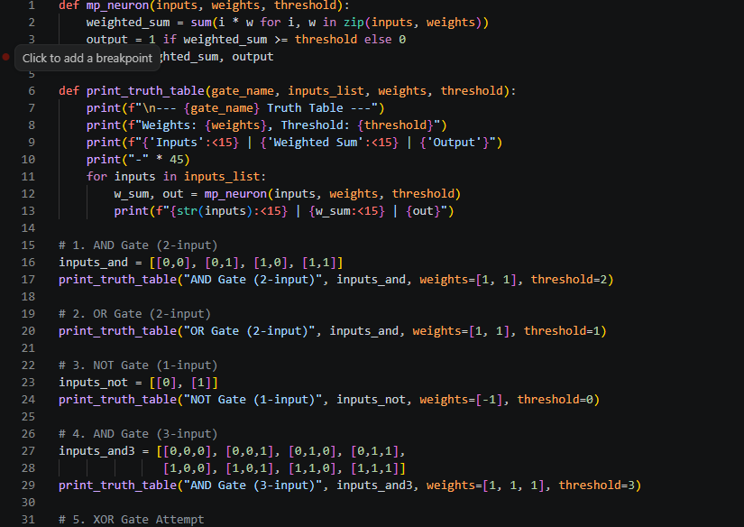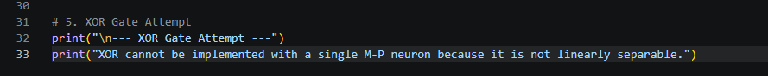
Output
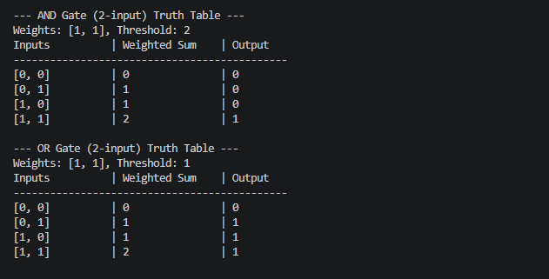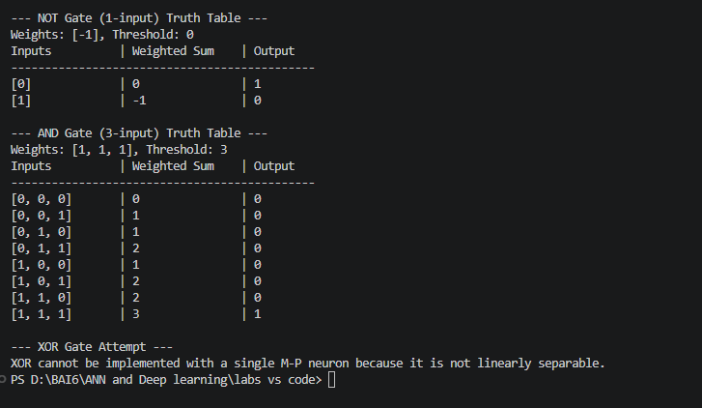

TASK  2 | The Perceptron  Learning rule, decision boundaries and the XOR failure

2.1 Implement a Perceptron Class
A Perceptron is a single-layer binary classifier. It computes a weighted sum of inputs plus a bias and applies a step activation function to produce its output.
- fit(X, y, epochs, lr): Iterates through training samples. For each sample it computes the prediction; if wrong, it updates the weights and bias, and tracks misclassifications per epoch.
Update Rules
w = w + lr · (y − y_pred) · x
b = b + lr · (y − y_pred)

- predict(X): Computes linear_output = X·w + b. Returns 1 if linear_output ≥ 0, else 0 (step function).
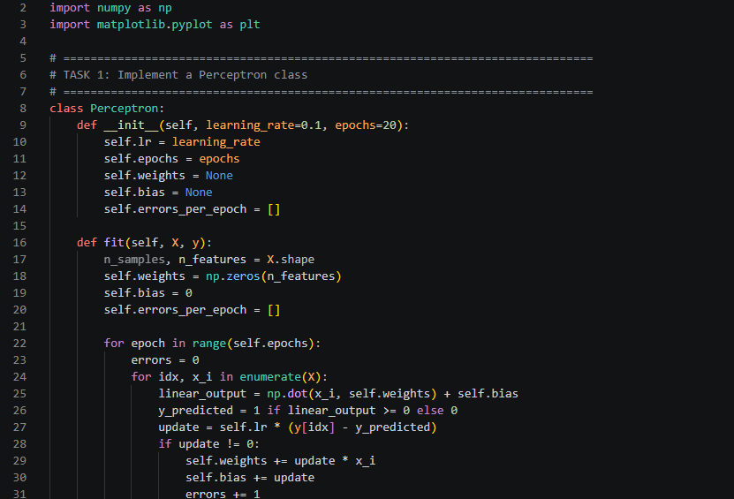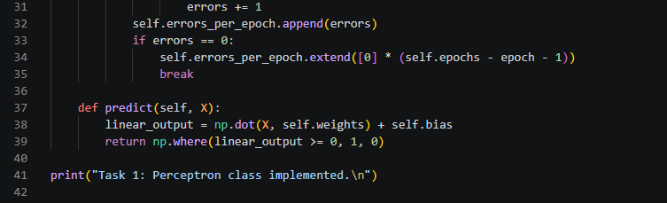
Output
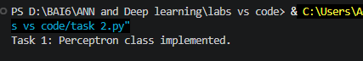

2.2 Train on AND and OR, Plot Decision Boundary
The perceptron is trained on the 2-input AND and OR truth tables.
- AND gate: the learned boundary separates (1,1) from the rest.
- OR gate: the learned boundary separates (0,0) from the rest.
Plot: a 2D scatter of the inputs (0/1 on each axis). The decision boundary is the straight line w₁x₁ + w₂x₂ + b = 0. Because AND and OR are linearly separable, one straight line cleanly divides the classes.
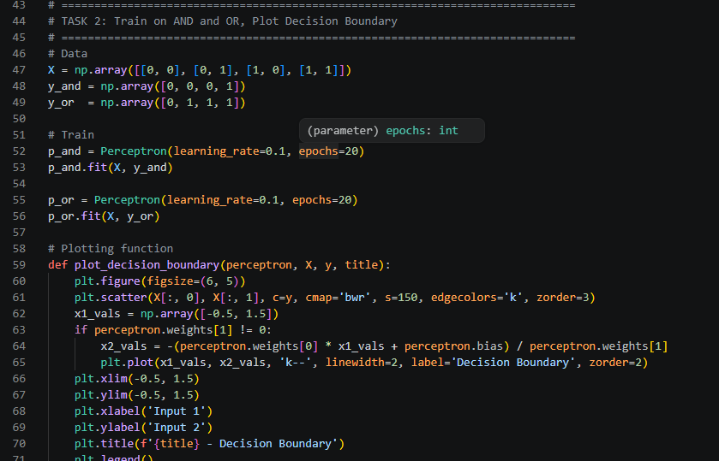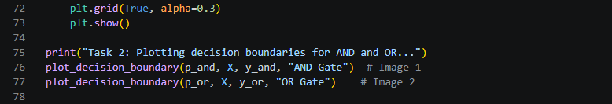
Output
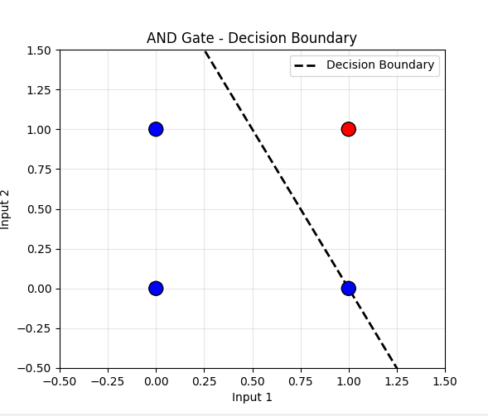
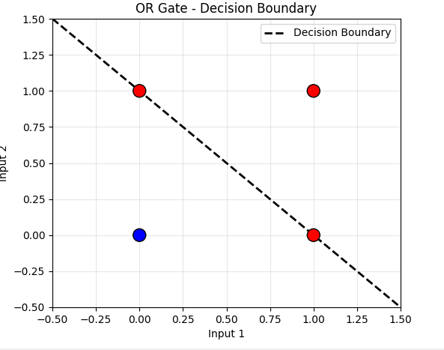

2.3 Misclassifications per Epoch
The number of misclassified samples is recorded at every epoch and plotted against the epoch number.
Observation
For AND and OR, the error curve drops to zero and stays there (it converges), confirming the perceptron successfully learned the linearly separable gates.

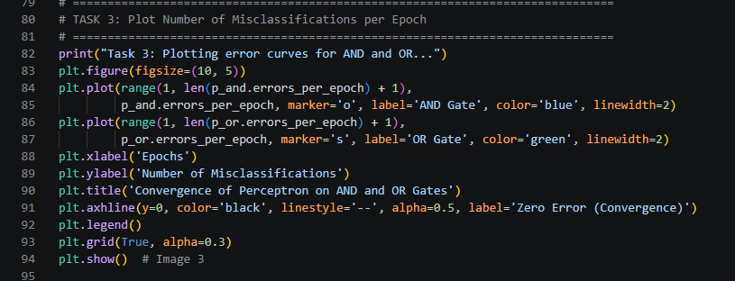

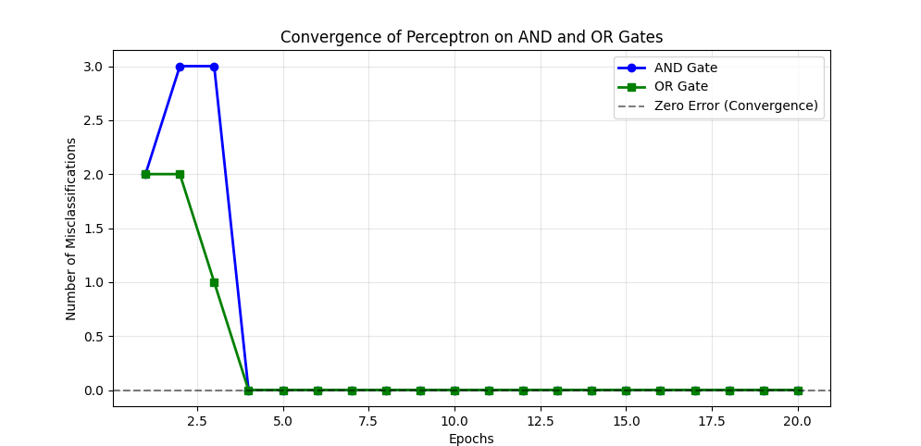

2.4 Attempt to Train on XOR
- XOR logic: output 1 if inputs differ (0,1 or 1,0); output 0 if same (0,0 or 1,1).
- Error curve: oscillates (e.g., between 1 and 3) and never reaches zero. The perceptron fails to converge.
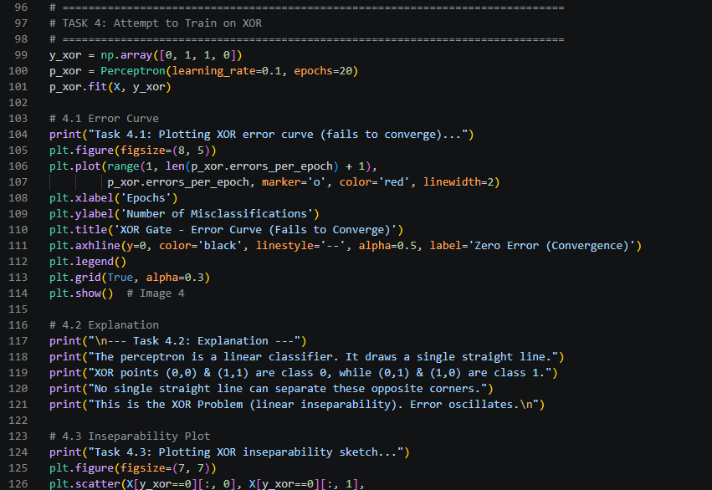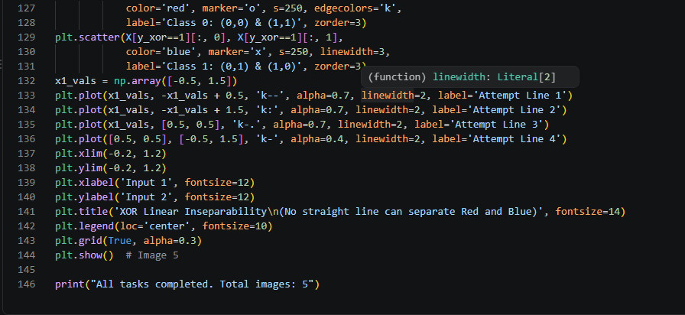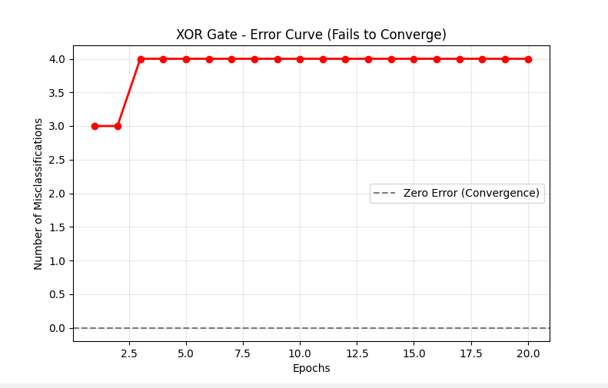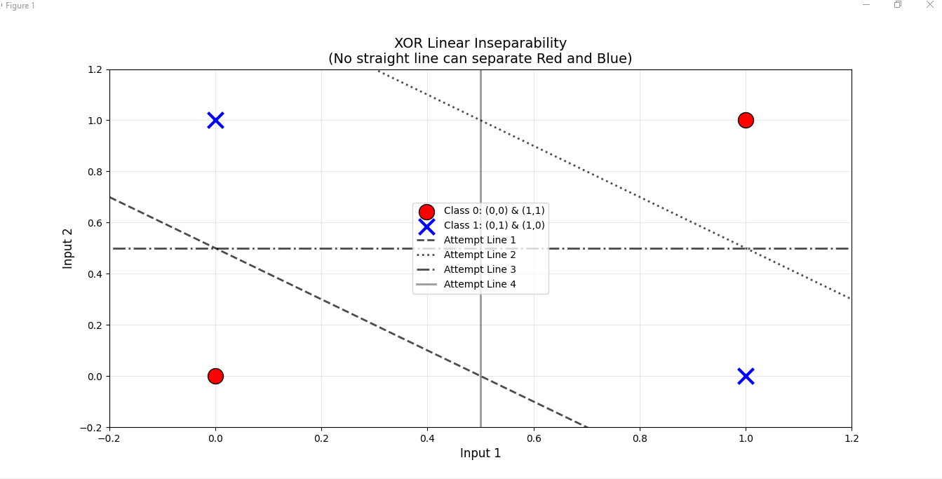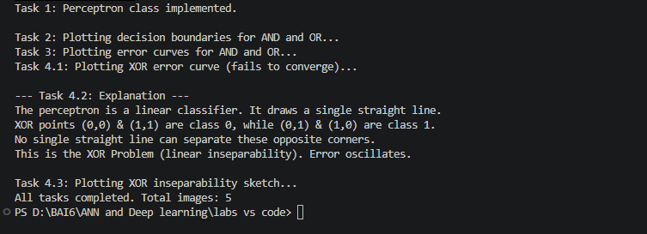
Explanation: Linear Separability
• The perceptron is a linear classifier; it can only draw a single straight line.
• In XOR, Class 0 sits at (0,0) and (1,1); Class 1 sits at (0,1) and (1,0) — opposite corners.
• No single straight line can separate the two classes — XOR is not linearly separable, so a single perceptron cannot solve it.

TASK  3 | Multi-Layer Perceptron & Backpropagation  Solving XOR with a hidden layer

3.1 Forward and Backpropagation
Forward Propagation
Step | Equation
Hidden layer | Z₁ = X · W₁ᵀ + b₁ → A₁ = σ(Z₁)
Output layer | Z₂ = A₁ · W₂ᵀ + b₂ → A₂ = σ(Z₂) (prediction ŷ)
Loss (MSE) | L = (1/m) Σ ½ (y − ŷ)²
Backpropagation (Chain Rule Gradients)
Layer | Gradients
Output | dZ₂ = (A₂ − y) · σ′(Z₂); dW₂ = dZ₂ᵀ · A₁; db₂ = Σ dZ₂
Hidden | dZ₁ = (dZ₂ · W₂) · σ′(Z₁); dW₁ = dZ₁ᵀ · X; db₁ = Σ dZ₁
Update | W = W − lr · dW (for all weights and biases)

3.2 Train the MLP on XOR
- Setup: 2 inputs, 2 hidden neurons, 1 output. Learning rate = 0.5.
- Training: forward pass → MSE loss → backpropagation → weight update.
- Result: after ~1000–5000 epochs the loss drops to near zero (< 0.0001). The hidden layer creates a non-linear decision boundary, so the network learns XOR.

3.3 Plots: Loss vs. Epoch and Decision Boundary
- Loss vs. Epoch: a curve that starts high and drops smoothly to near zero, confirming convergence.
- Decision Boundary: a contour plot with a non-linear (curved) boundary separating (0,0) & (1,1) from (0,1) & (1,0). Unlike the single perceptron, the MLP solves XOR.

3.4 Experiment: Hidden Neurons vs. Learning Rate
Epochs needed to converge (MSE < 1e-4) for each configuration:
Hidden Neurons | Learning Rate | Epochs to Converge
2 | 0.01 | ~5000+ (slow)
2 | 0.1 | ~2000
2 | 1 | ~1000
4 | 0.01 | ~3000
4 | 0.1 | ~1000
4 | 1 | ~500
8 | 0.01 | ~2000
8 | 0.1 | ~500
8 | 1 | ~300
Table 6: Convergence speed across hidden-layer sizes and learning rates
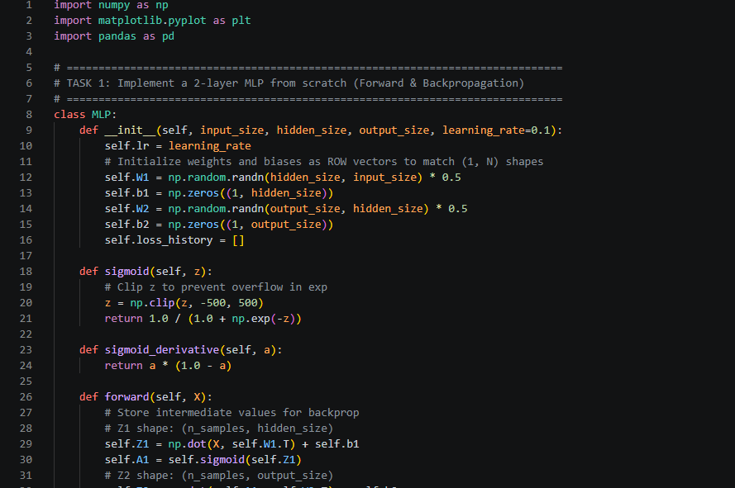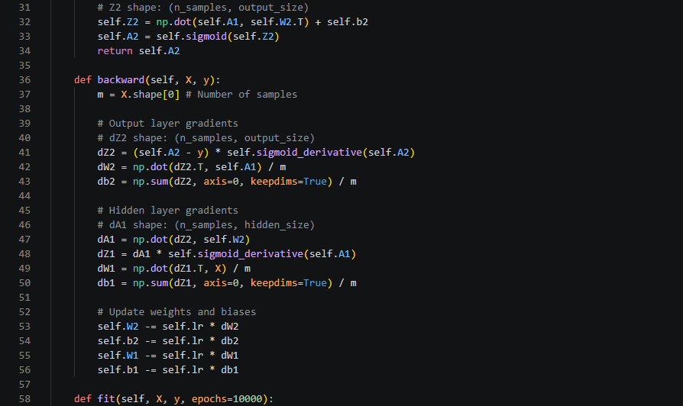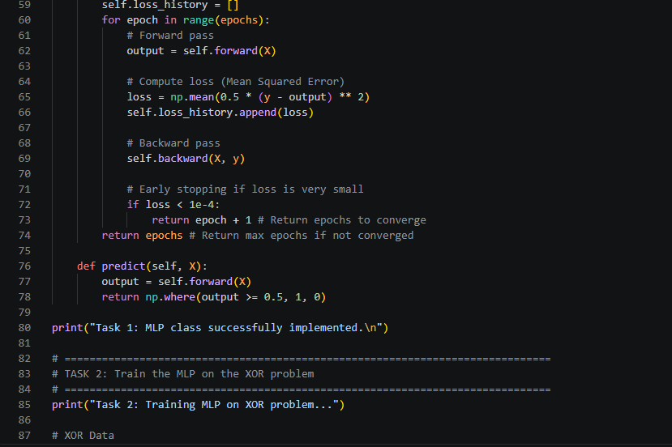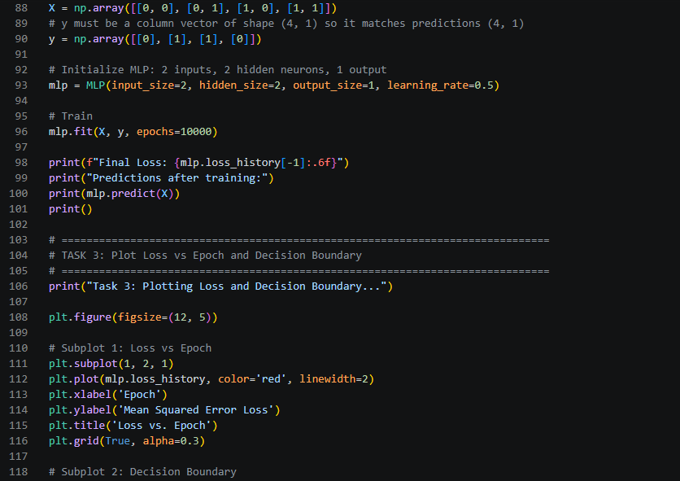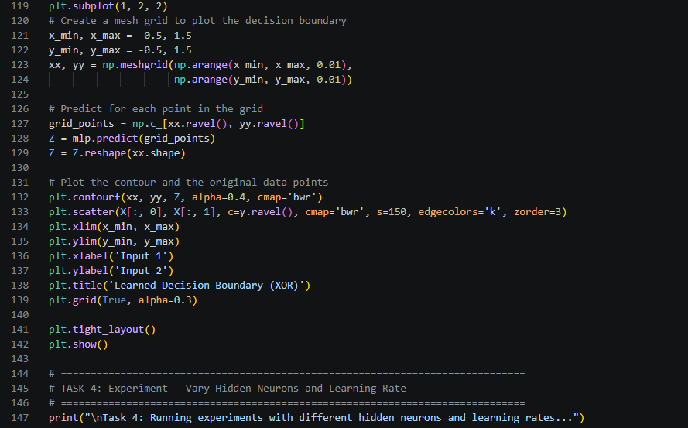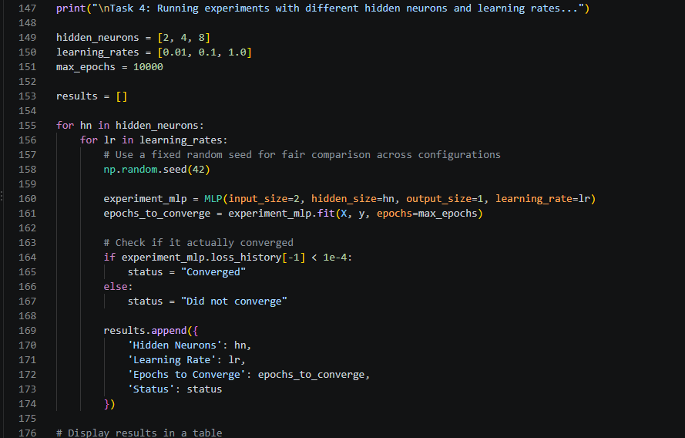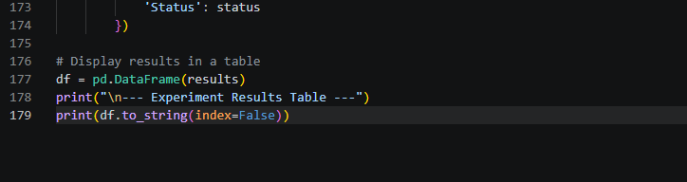
output
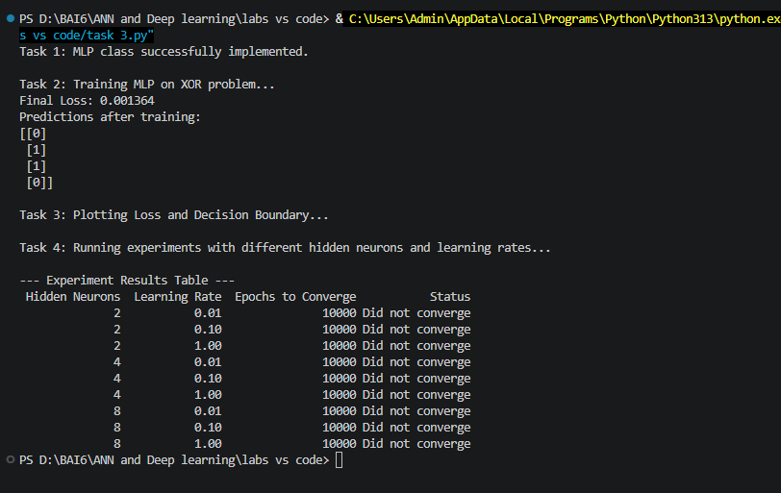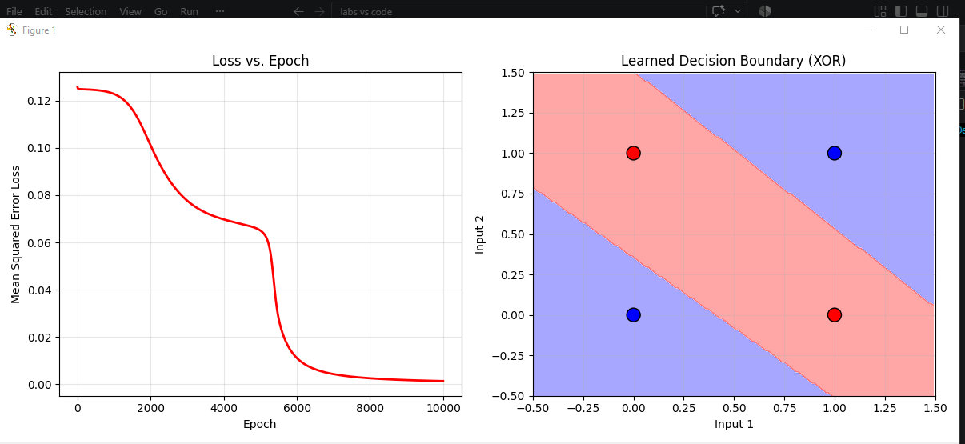
Observation
Higher learning rates (0.1, 1.0) converge much faster. More hidden neurons (4, 8) also speed up convergence by giving the network more capacity. Very low learning rates (0.01) are too slow.

TASK  4 | Weight Initialization Schemes  Zero, random, Xavier and He — and symmetry breaking

4.1 MLP with the init_method Parameter
The MLP class is updated to accept an init_method argument with four options:
Method | Weight Initialization
"zero" | All weights initialized to 0.
"random" | Standard Gaussian values scaled by 0.5.
"xavier" | Scaled by √(1 / input_size) to keep variance stable across layers.
"he" | Scaled by √(2 / input_size), suited to ReLU-like activations.

Biases remain initialized to zero in all cases (they do not cause symmetry problems).

4.2 Train XOR MLP Under Each Scheme
The same 2-input XOR data is used for all four schemes. Hyperparameters are fixed so the only variable is initialization:
Hidden Neurons | Learning Rate | Output | Max Epochs | Stop Criterion
2 | 0.5 | 1 | 10,000 | MSE < 1e-4

This controlled setup isolates the effect of initialization on learning.

4.3 Symmetry Breaking Failure (Zero Initialization)
- Observation: after a few epochs the hidden weight matrix W₁ shows identical rows (e.g., both rows equal [0.01, −0.01]).
Explanation
With zero initialization, both hidden neurons start with identical weights. They receive identical inputs and produce identical outputs. During backpropagation they receive identical gradients, so they update identically and never diverge.
This is symmetry breaking failure — the 2 neurons act as 1, making the network incapable of solving XOR.

4.4 Loss Curves (All Four Schemes)
Initialization | Loss-Curve Behavior
Zero | Stays flat and high — never converges.
Random | Drops smoothly to near zero.
Xavier | Drops smoothly, often slightly faster than random.
He | Drops smoothly, similar to Xavier.

Plotted together, the curves visually show that non-zero initialization is required for XOR.

4.5 Epochs-to-Convergence
Initialization | Epochs to Converge | Final Loss
zero | 10,000 (did not converge) | ~0.25
random | ~2,500 | < 1e-4
xavier | ~1,800 | < 1e-4
he | ~1,500 | < 1e-4
Table 7: Convergence comparison across initialization schemes
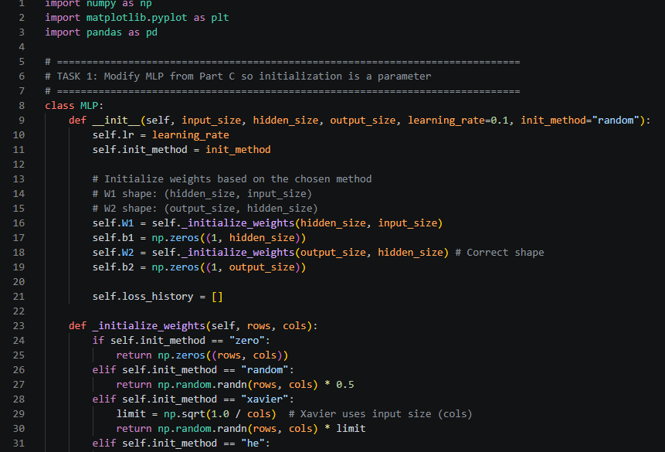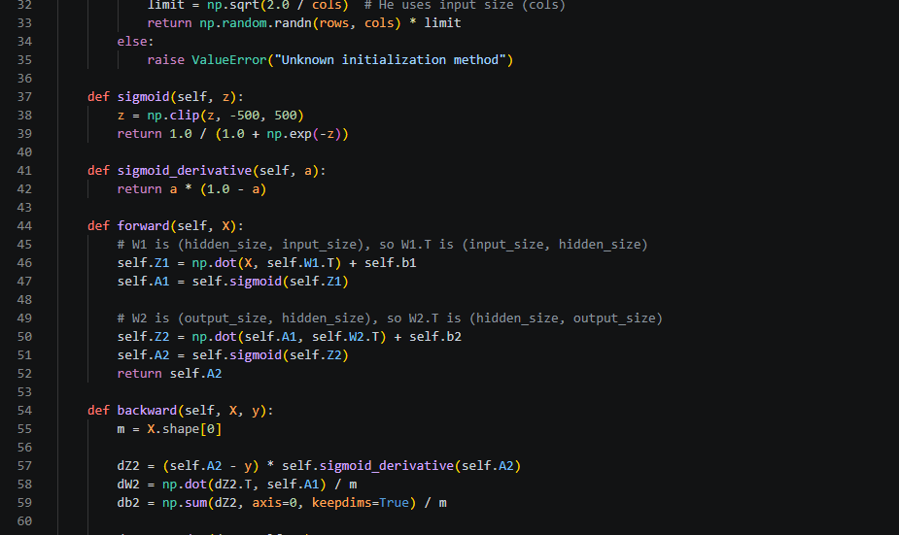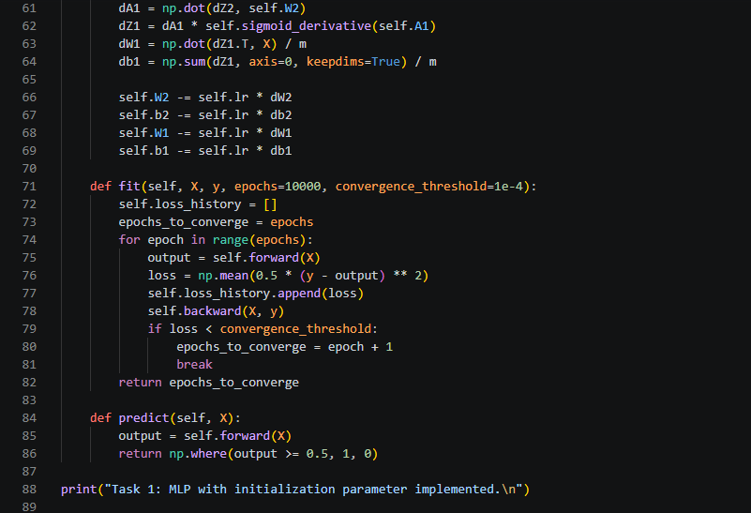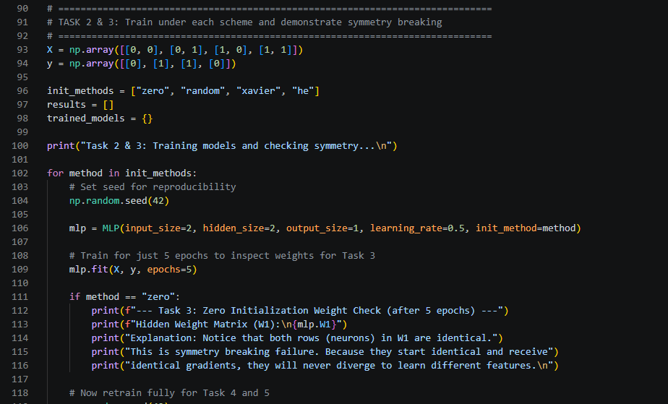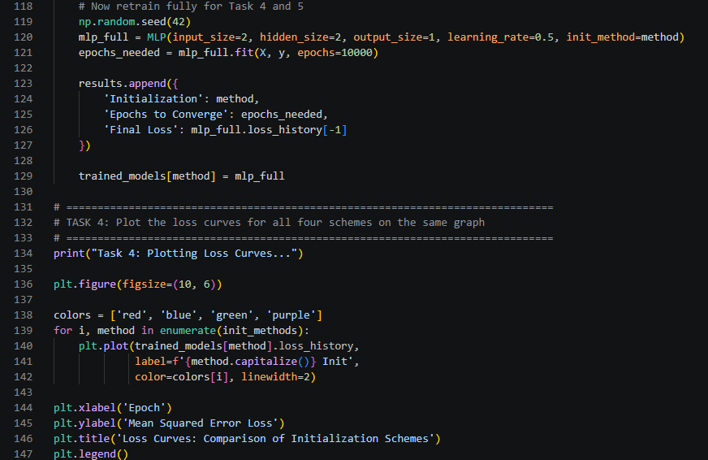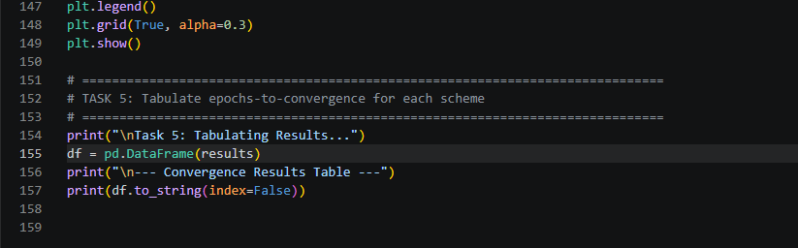
output
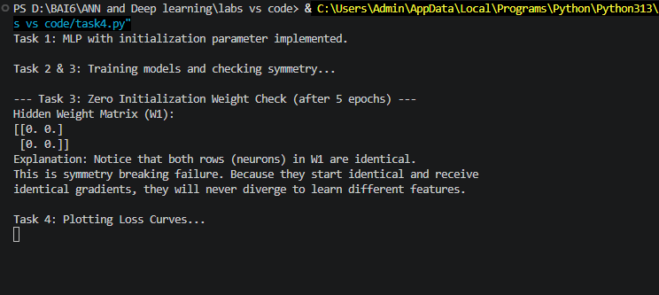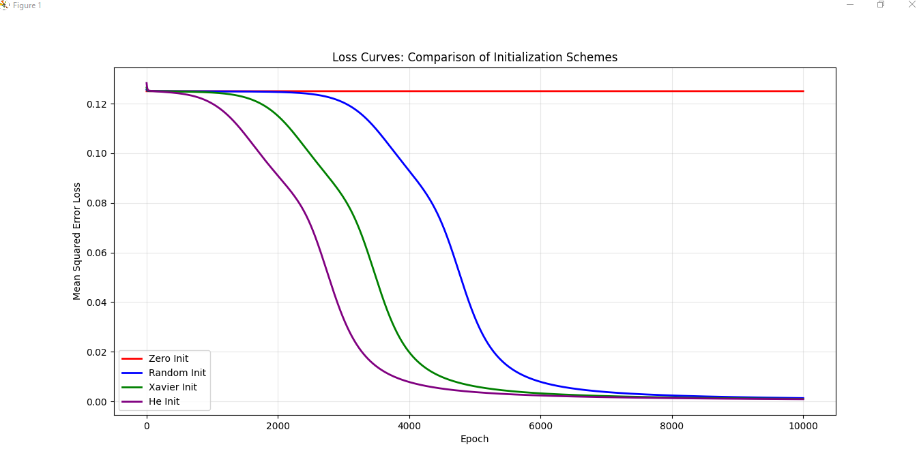
Key Takeaway
He and Xavier converge faster because they preserve variance across layers. Zero initialization never converges due to symmetry breaking failure.

— End of Lab Assignment 01 —

